# Assessment Parameters

* Complete flow of the application  with validation and exception handling -70%
* Comments/best practice, coding standards – 10%
* Execution of the application (Output) – 20%
* Screenshot should be submitted along with the solution
* The solution(Project) created by the trainee should have the name like AppName_Empid Ex:ABCCorp_675467
* Code with compilation errors will not be considered for evaluation

# Maintaining ODI Cricket Score Records

**Requirement:**

Develop a web application for the International Cricket Council for storing and maintaining ODI Cricket Score Records of all the International Cricket Player’s worldwide maintaining Details about Players info and their ODI records data.

The application should provide the following functionalities:

**Home Page(is optional),** when the application is run it should retrieve the existing records of cricket players and their score data from the database and display on the ViewPlayerspage**(Showing Existing Player Records)** as shown below.

# 

*Note: Age should be calculated from date of birth data from database table and displayed on the page as above.*

**New Player Scores Data Entry Form:**

The user should be able to enter a new Player’s records into the system by clicking on the **Add New Player** link provided on the home page which displays the “New Player Score Entry form “as shown below.

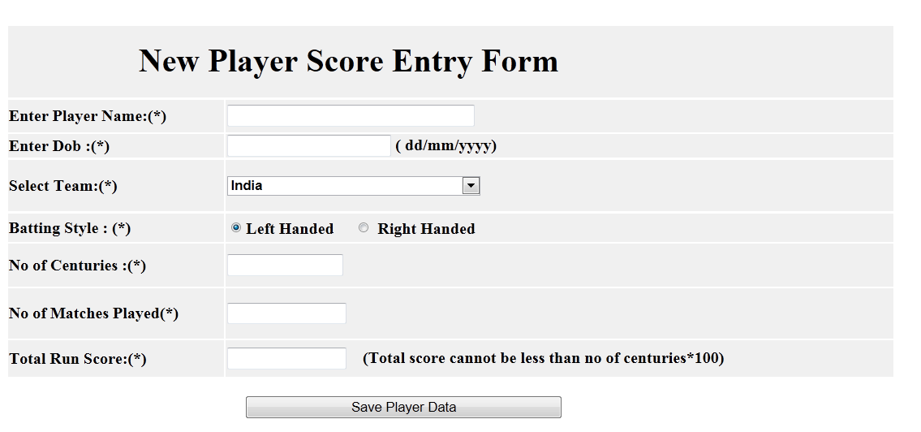

The data entered into the Sore Entry Form must be validated as follows:

* All the fields are compulsory
* Total run score cannot be negative
* Player Id should be auto generated.
* Team drop down list should contain values India, UK, Shrilanka, Australia and Zimbawe.

*Note: All validations are to be done using html 5.* *Proper validation error messages are to be displayed* in the same page.

When all data entered correctly in the form, it should display the success message in the next page with “successful record insertion” message.

**InsertSuccess.jsp**

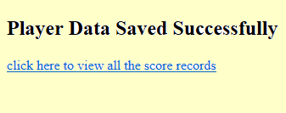

**Application Flow:**

Home.jsp (optional)

Error.jsp

ViewPlayers.jsp

**<<Service>>**

**CricketServiceImpl**

DB

**<<Controller>> CricketScoreController**

**<<DAO>>**

**CricketScoreDAOO**

InsertSucess.jsp

PlayerBean

NewPlayer.jsp

**TABLE SCRIPT**

**CREATE TABLE cricket_score(player_id NUMBER PRIMARY KEY,player_name VARCHAR2(40),dob DATE, country VARCHAR2(40),batting_style VARCHAR2(20),centuries NUMBER,matches NUMBER, total_run_score NUMBER);**

**CREATE SEQUENCE player_seq;**

INSERT INTO cricket_score VALUES(player_seq.NEXTVAL,'Sachin Tendulkar','24-APR-1973','India','Right Handed Batsman',49,463,18426);

INSERT INTO cricket_score VALUES(player_seq.NEXTVAL,'R.T Ponting','19-DEC-1974','Australia','Left Handed Batsman',30,375,13704);

INSERT INTO cricket_score VALUES(player_seq.NEXTVAL,'S.T Jayasuriya','30-JUN-1969','Shrilanka','Right Handed Batsman',28,445,13480);

INSERT INTO cricket_score VALUES(player_seq.NEXTVAL,'S.C Ganguly','8-JUL-1972','India','Left Handed Batsman',22,311,11363);

**Mark Distribution**

|  |  |
| --- | --- |
| View Players Page (Home page) | 10 |
| Add Player Form page | 10 |
| Success Page | 5 |
| Error Page | 3 |
| LeaveController: | 10 |
| Buisiness components/ Beans/Service classes: | 5 |
| EmpLeaveDAO: Must process all database operations. | 10 |
| Exception Handling | 5 |
| Form Validations | 7 |
| Coding standards | 5 |